 | Massachusetts Department of Environmental Protection  Bureau of Resource Protection - Wetlands  Request for Departmental Action Fee Transmittal Form  Massachusetts Wetlands Protection Act M.G.L. c. 131, §40 |  |  | DEP File Number:  Provided by DEP
 | A. Request Information
 | 1. Location of Project
 | a. Street Address | b. City/Town, Zip
 | c. Check number | d. Fee amount
Important: When filling out forms on the computer, use only the tab key to move your cursor - do not use the return key.  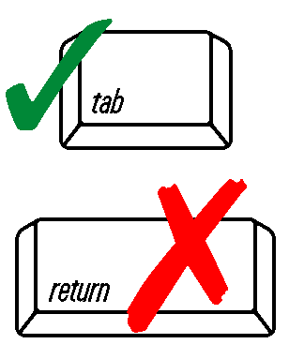 | 2. Person or party making request (if appropriate, name the citizen group’s representative):
 | Name
 | Mailing Address
 | City/Town |  | State |  | Zip Code
 | Phone Number |  | Fax Number (if applicable)
 | 3. Applicant (as shown on Notice of Intent (Form 3), Abbreviated Notice of Resource Area Delineation (Form 4A); or Request for Determination of Applicability (Form 1)):
 | Name
 | Mailing Address
 | City/Town |  | State |  | Zip Code
 | Phone Number |  | Fax Number (if applicable)
 | 4. DEP File Number:
 | B. Instructions
 | 1. When the Departmental action request is for (check one):
 | Superseding Order of Conditions – Fee: $120.00 (single family house projects) or $245 (all other projects)
 | Superseding Determination of Applicability – Fee: $120
 | Superseding Order of Resource Area Delineation – Fee: $120
Send this form and check or money order, payable to the Commonwealth of Massachusetts, to:

Department of Environmental Protection
Box 4062
Boston, MA 02211
 | B. Instructions (cont.)
2. On a separate sheet attached to this form, state clearly and concisely the objections to the Determination or Order which is being appealed. To the extent that the Determination or Order is based on a municipal bylaw, and not on the Massachusetts Wetlands Protection Act or regulations, the Department has no appellate jurisdiction.

3. Send a copy of this form and a copy of the check or money order with the Request for a Superseding Determination or Order by certified mail or hand delivery to the appropriate DEP Regional Office.

4. A copy of the request shall at the same time be sent by certified mail or hand delivery to the Conservation Commission and to the applicant, if he/she is not the appellant.

